1. Hist equal (int) 🡪 threshold (isodata) : 127.00000

Hist equal (int) 🡪 smooth (3)🡪 threshold (isodata) : 114.00000

Hist equal (int) 🡪 smooth (5)🡪 threshold (isodata) : 108.00000

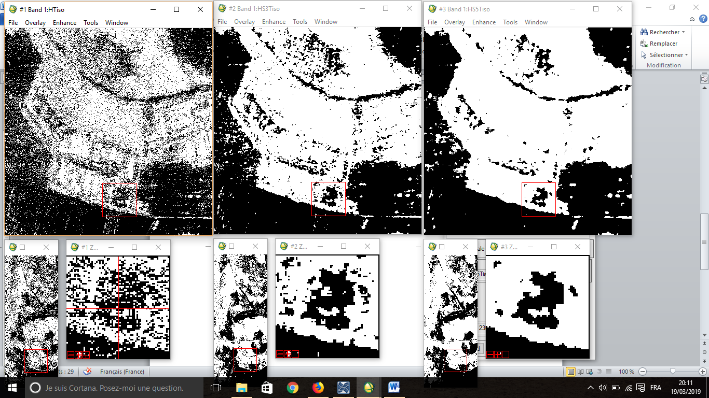

1. Hist equal (int) 🡪 threshold (isodata) : 127.00000

Hist equal (int) 🡪 smooth (3)🡪 threshold (isodata) : 114.00000

Smooth (sqrt-Int,3)🡪 Hist equal (int) 🡪 threshold (isodata) : 128.00000

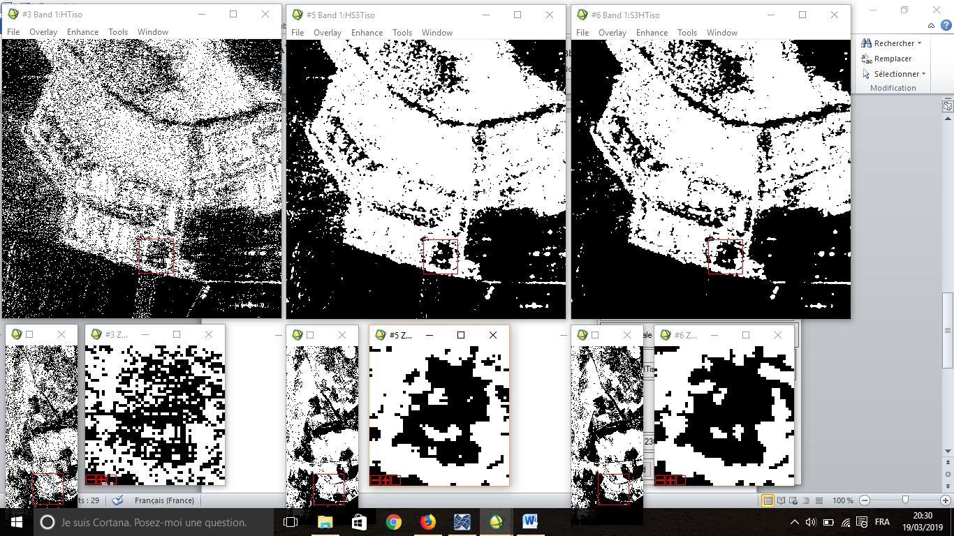

1. Comparaison entre différentes méthodes du thresholding  :

**pro** **thresholdcomp**

nbc=**925**

nbl=**2300**

x=**0**

y=**0**

**openr**,**1**,'C:\Users\Oussama\Desktop\nv\Données\slc1_hh_swap_925_2300'

image=**complexarr**(**925**,**2300**)

**readu**,**1**,**image**

**close**,**1**

HH=**extrac**(image,x,y,nbc,nbl)

image=**0**

absHH=**abs**(HH)

intHH=**abs**(HH^**2**)

R1 = **HIST_EQUAL**( **sqrt**(intHH))

Result1 = **IMAGE_THRESHOLD**(r1, /BYIMAGE, INTERLEAVE=**2**, THRESHOLD=T1 , /ISODATA )

**print**,'T1=',T1

Result2 = **IMAGE_THRESHOLD**(r1, /BYIMAGE, INTERLEAVE=**2**, THRESHOLD=T2 , /MAXENTROPY) **print**,'T2=',T2

Result3 = **IMAGE_THRESHOLD**(r1, /BYIMAGE, INTERLEAVE=**2**, THRESHOLD=T3 , /MEAN ) **print**,'T3=',T3

Result4 = **IMAGE_THRESHOLD**(r1, /BYIMAGE, INTERLEAVE=**2**, THRESHOLD=T4 , /MINERROR )

**print**,'T4=',T4

Result5 = **IMAGE_THRESHOLD**(r1, /BYIMAGE, INTERLEAVE=**2**, THRESHOLD=T5 , /MOMENTS )

**print**,'T5=',T5

Result6 = **IMAGE_THRESHOLD**(r1, /BYIMAGE, INTERLEAVE=**2**, THRESHOLD=T6 , /OTSU )

**print**,'T6=',T6

**openw**,**1**,'C:\Users\Oussama\Desktop\nv\Travail\Image Threshold\absimg'

**writeu**,**1**,absHH

**close**,**1**

**openw**,**1**,'C:\Users\Oussama\Desktop\nv\Travail\Image Threshold\intimg'

**writeu**,**1**,intHH

**close**,**1**

**openw**,**1**,'C:\Users\Oussama\Desktop\nv\Travail\Image Threshold\comp\HTiso'

**writeu**,**1**,result1

**close**,**1**

**openw**,**1**,'C:\Users\Oussama\Desktop\nv\Travail\Image Threshold\comp\HTmaxentropy'

**writeu**,**1**,result2

**close**,**1**

**openw**,**1**,'C:\Users\Oussama\Desktop\nv\Travail\Image Threshold\comp\HTmean'

**writeu**,**1**,result3

**close**,**1**

**openw**,**1**,'C:\Users\Oussama\Desktop\nv\Travail\Image Threshold\comp\HTminrror'

**writeu**,**1**,result4

**close**,**1**

**openw**,**1**,'C:\Users\Oussama\Desktop\nv\Travail\Image Threshold\comp\HTmoments'

**writeu**,**1**,result5

**close**,**1**

**openw**,**1**,'C:\Users\Oussama\Desktop\nv\Travail\Image Threshold\comp\HTotsu'

**writeu**,**1**,result6

**close**,**1**

**stop**

**end**

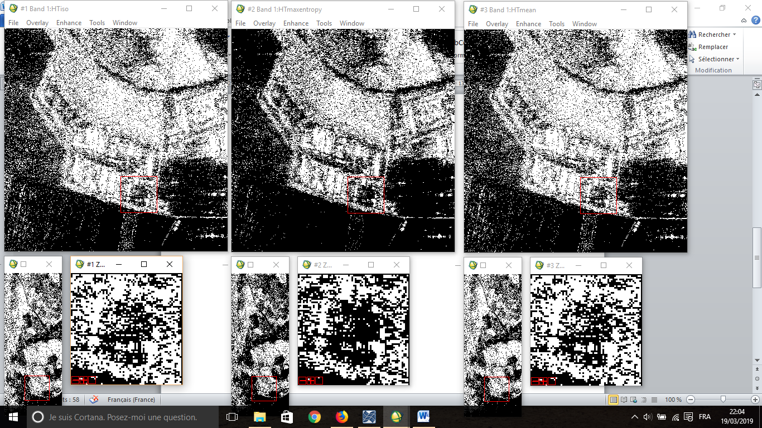

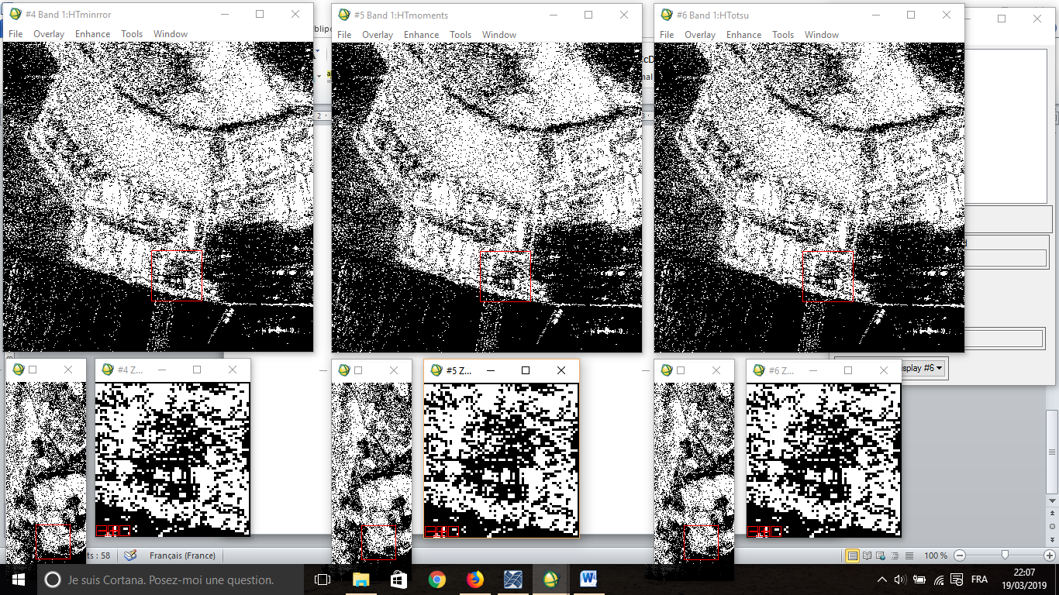

**T1**=127.00000,**T2**=155.00000,**T3**=128.00000,**T4**=128.00000,**T5**=128.00000,**T6**=128.00000

1. Comparaison entre différentes méthodes du thresholding après le smooth :

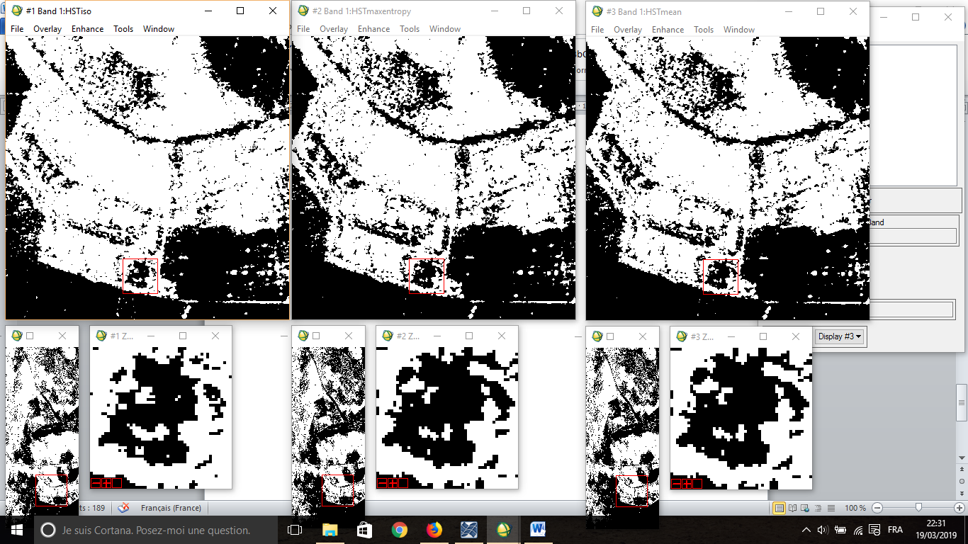

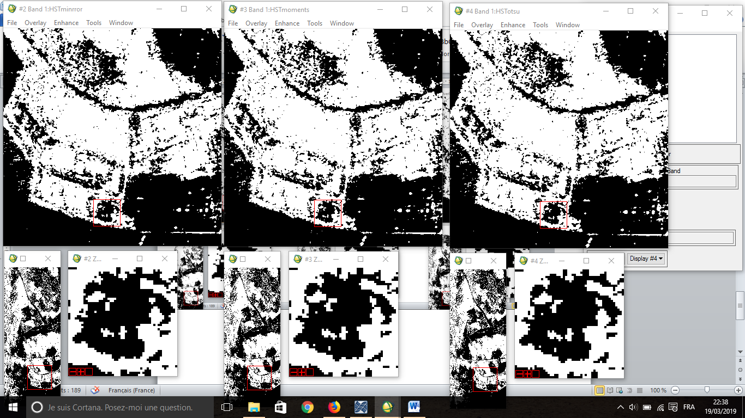

**T1**=114.00000,**T2**=128.00000,**T3**=127.00000,**T4**=131.00000,**T5**=127.00000,**T6**=128.00000